ELEC ENG 3TP3 – Lab 1
MATLAB Introduction and Refresher

Amaiam Ul Haque – haquea24 – 400520641
Dr. Thia Kirubajan
October 21st, 2025

Notes
- All descriptions necessary are comments within the code.

- Save the current figure using:
exportgraphics(gcf, 'filename_you_want.jpg');
This method will strip off excess whitespace around the figure.

- Place text on each graph:
text(100, 1, 'Amaiam Ul Haque, 400520641', 'FontSize', 11);
Will place Amaiam Ul Haque at coordinate location (100, 1) on the current plot.

- Must include Matlab and how it works in the comments.

- %% = bolded and sectioned comment (like a header)

- To plot multiple signals:
X = linspace(0,2*pi,50)';
Y = [cos(X), 0.5*sin(X)];
stem(Y)
Or:
stem(signal1); hold on;
stem(singal2);
From MATLAB Help Center – Stem page (right click on any stem usage in Matlab editor and select Help on “stem” option).

Question 1

Part a)
Code:
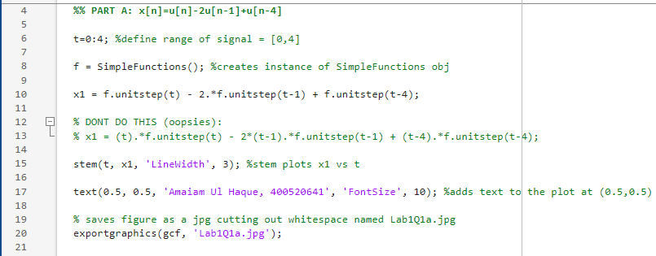
Plot:
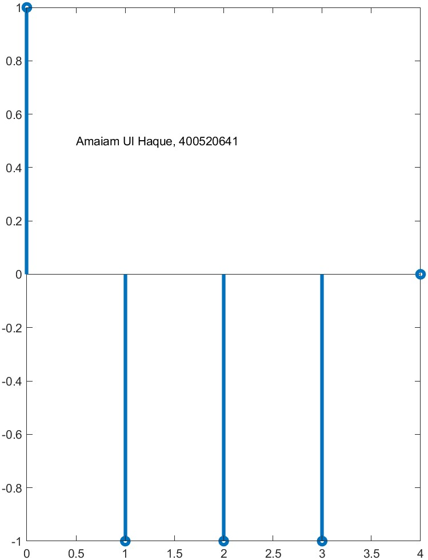

Part b)
Code:
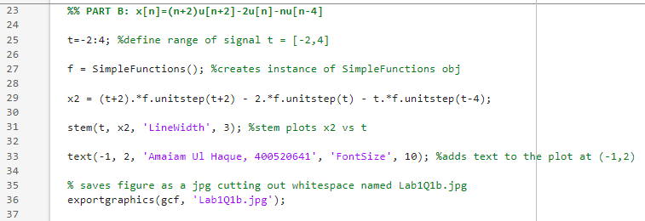
Plot:
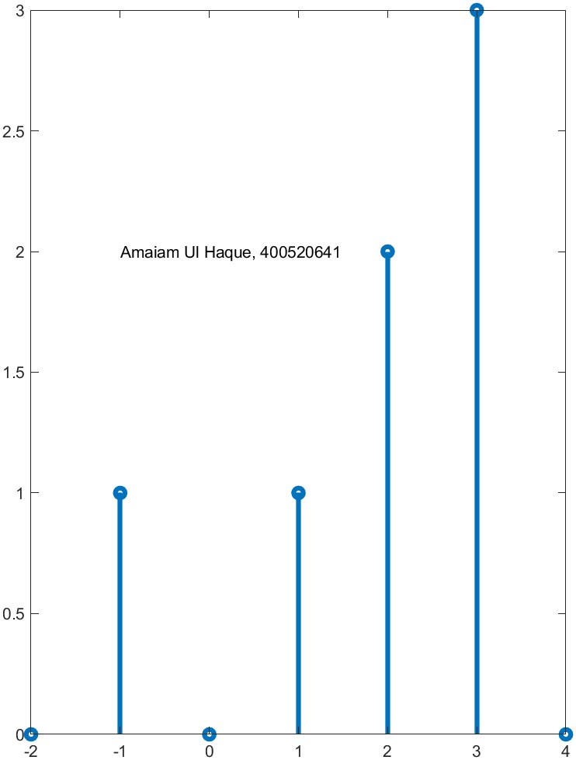

Part c)
Code:
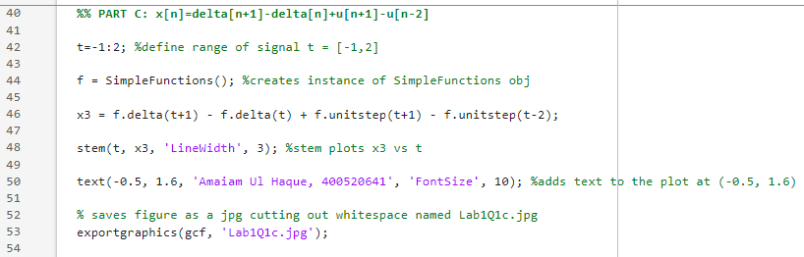
Plot:
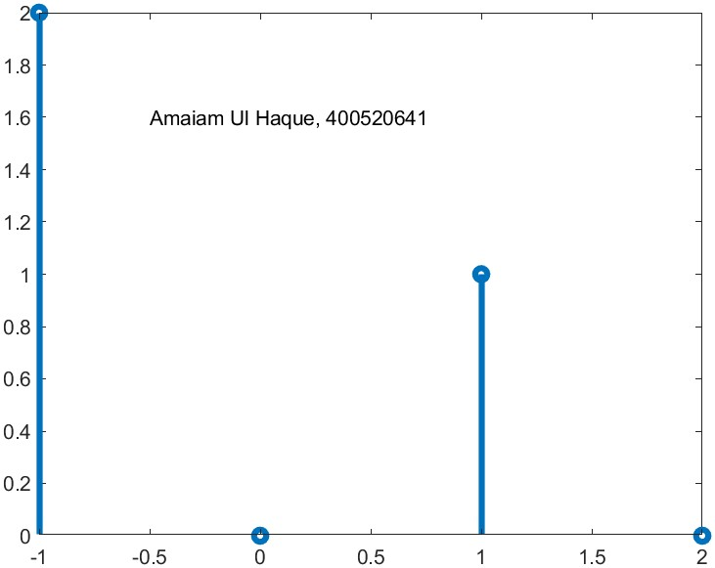

Part d)
Code:
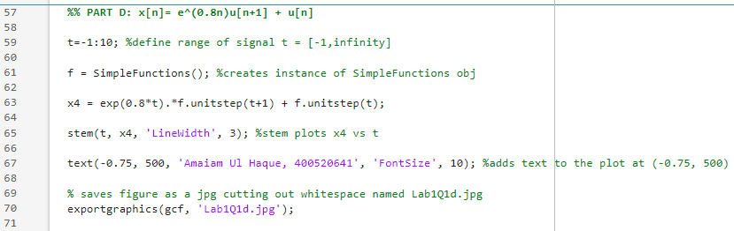
Plot:
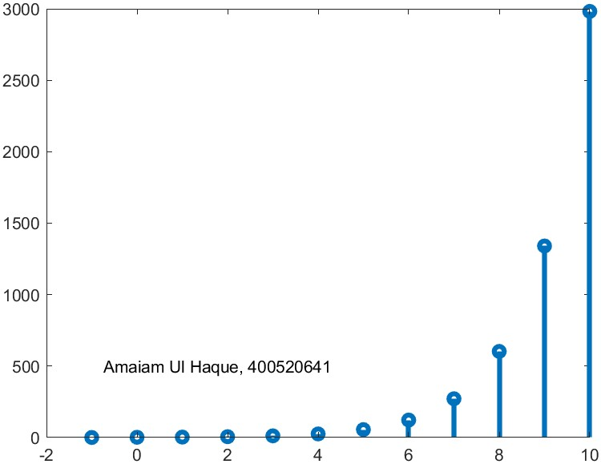

Part 2
Code used for each part (abcd):
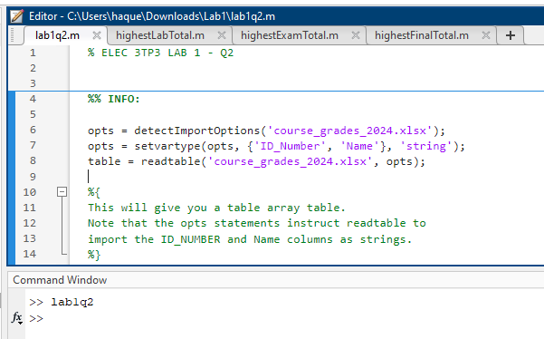

Part a)
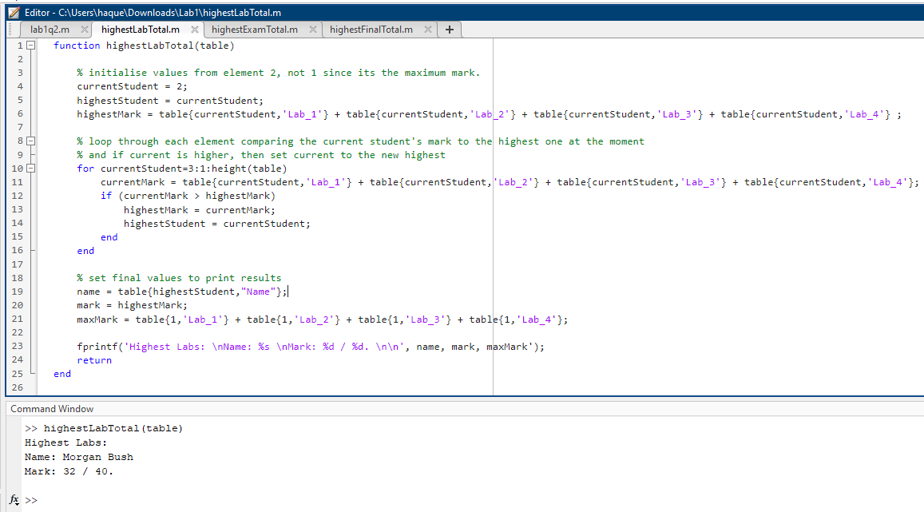

Part b)
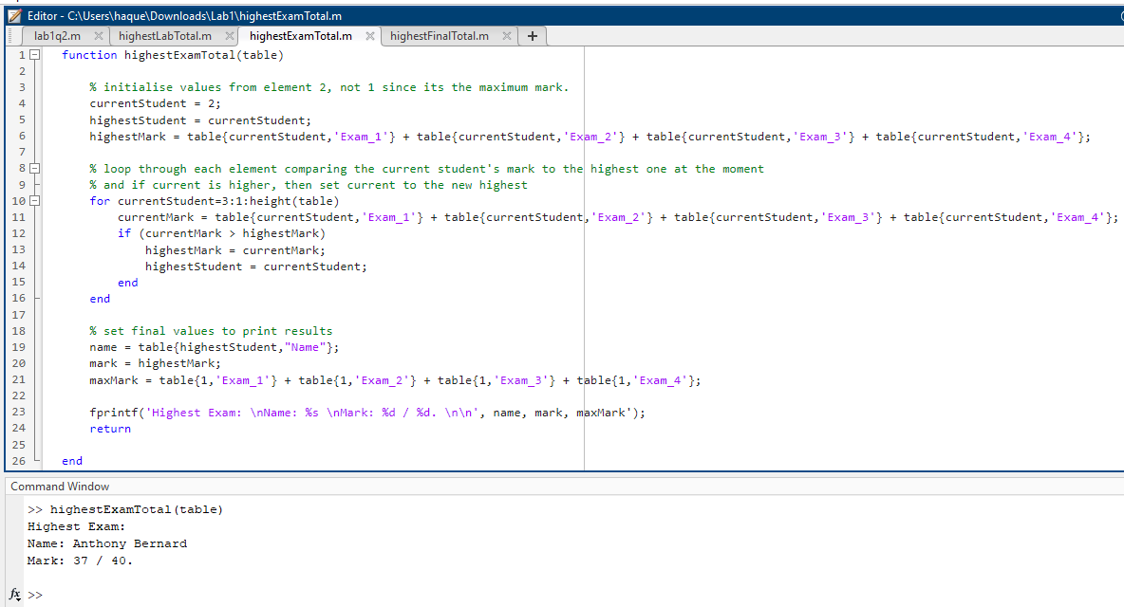

Part c)
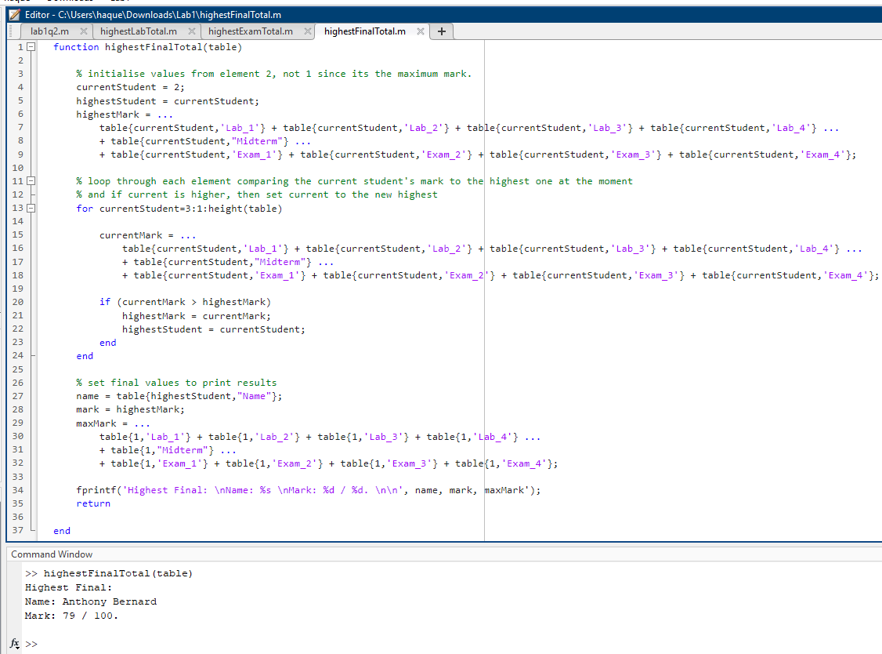

Part d)
Code:
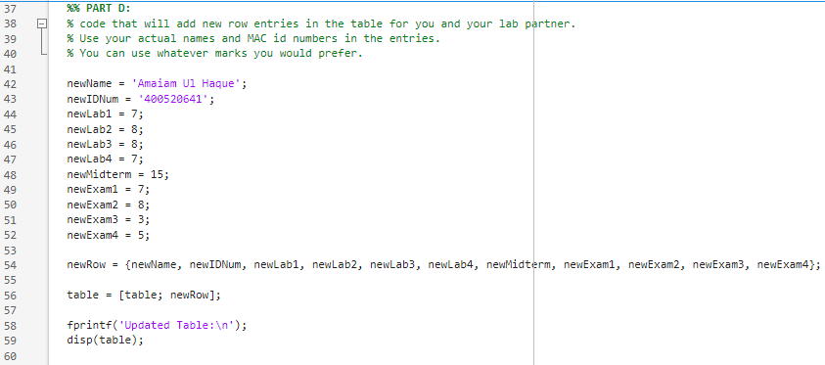
Result:
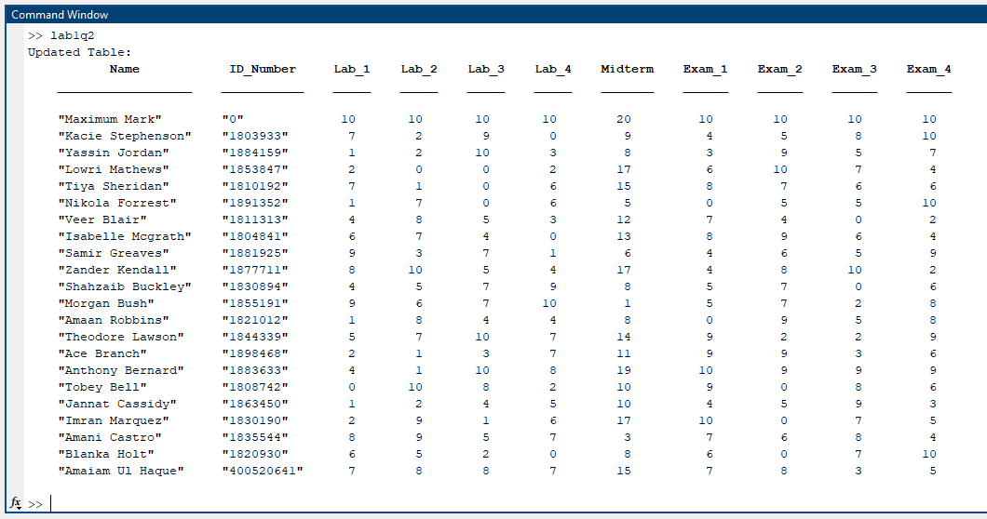

Part 3
Code:
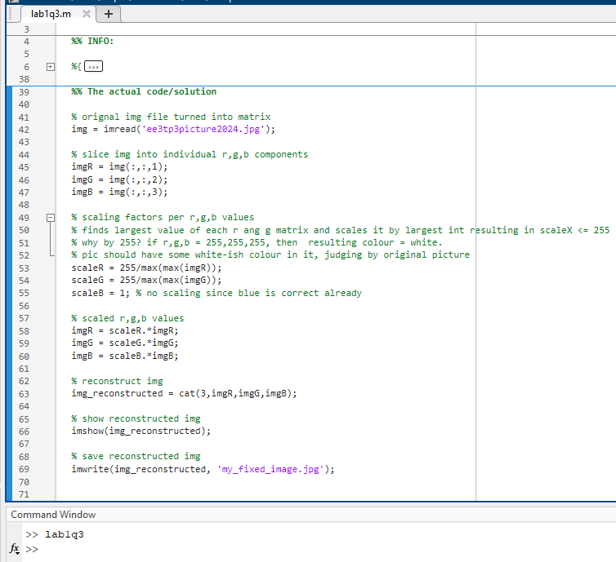

Scaling factors:
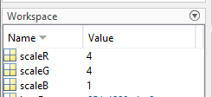
Resulting image:


